MECH 460: Proposal Report

**Team 04C: Exterior Shell on Queen’s Super Milage Team**

Ethan Hsiao

Joshua Sass-Gregoire

Matthew Thoms

Hao Xue

Yan Zhou

Keith Pilkey

MECH 460: Team Project, Conceive & Design  
Department of Mechanical & Materials Engineering  
Queen’s University

**Executive Summary**

The Queen’s Supermileage team will be competing in the 2023 Shell eco-marathon regional competition that will be taking place in Indianapolis Motor Speedway in the United States. Collaborating closely with the faculty of Applied science and Engineering and the Department of Mechanical and Materials Engineering to provide members with a supplementary learning for their in-class studies.

The Queen’s Supermileage team, or QSM, is a student-run design team that aims to shape the future of fuel consumption. Shell eco-marathon has two separate classes of competition, prototype class and the urban concept class. QSM will be competing in the urban class which allows students to design and build energy efficient vehicles that are closer in appearance to modern passenger cars. The urban concept class will be focusing on “stop and go: driving in which the drivers will be driving at the minimum speed to allow the vehicle to compete the required laps in a designated time. The team who will conserve the most fuel will win.

Our team is focusing on the design and build of the exterior shell of the urban concept class vehicle. This exterior shell will include the panels, windows, doors and other small accessories that the exterior of the car may need. This report will focus on the preliminary design strategies, design criteria and design ideas that will be incorporated in the exterior shell of the next years vehicle. By examining the previous report of customer requirements and technical aspects that the exterior shell must exhibit, our group brainstormed ideas and used a design matrix to find the best option for the QSM team.

In this report there is an economic analysis to ensure that the parts or designs that our team has chosen is justified and has a clear reason why it is important for the QSM to have this design in their new concept class vehicle. With a budget of $8000 CAD, it is vital that our team ensures the designs and ideas are kept well below the required budget to account for inflation, shipping and other fees.

## Table of Contents

Table of Contents iii

1.0 Introduction 1

1.1 The Competition 1

2.0 Project Scope 1

3.0 Design Criteria and Functional Specifications 1

3.1 Design Benefits 2

4.0 Design Solutions 2

4.1 Design for Attachment 2

4.1.1 3D-Printed Mounting Assembly 3

4.1.2 Ball/Cushion Clip Mount 3

4.1.3 McMaster-Carr Weld Nut 4

4.1.4 Further remarks 4

4.2 Design for Doors 4

4.2.1 Door Handles – Yacht Flush Handle 5

4.2.2 Door Handles – Circular Latch 5

4.2.3 Door Handles – Recessed Pull Handle 6

4.2.4 Door Latches – Swinging hook latch 6

4.2.4 Door Latches – Snap latch 6

4.2.5 Door Latches – Bolt latch 7

4.2.6 Door Hinges – Hidden Circular Hinge 7

4.2.7 Door Hinges – Locking Lift-off Hinge 8

4.2.8 Door Hinges – Marine Hinge 8

4.3 Design for Exterior shell 8

4.3.1 Plain carbon 8

4.3.2 Twill carbon 9

4.3.3 plain weave S-glass 9

4.4 Design for Windows 10

4.4.1 Polycarbonate Sheet 10

4.4.2 Impact-Resistant Polycarbonate Film 10

4.4.3 Scratch and UV-Resistant Cast Acrylic Sheet 11

5.0 Selection Methodology 11

5.1 Proposed Design 11

5.1.1 Panel Attachments 11

5.1.2 Door Attachments 12

5.1.3 Exterior Panels 12

6.0 Deliverables 12

7.0 Economic Analysis 13

8.0 Conclusion 13

9.0 Appendix 13

**Table of Figures**

Figure 1: 3D-printed mounting system CAD model. 3

Figure 2: Image of cushion clip mount 3

Figure 3: Image of weld nut 4

Figure 4: Image of flush yacht handle. 5

[Figure 5: Image of flush circular latch with dimensions. 5](https://queensuca.sharepoint.com/teams/GROUP-Mech460QSMExteriorShell4C/Shared%20Documents/General/Proposal/MECH%20460%20Proposal%20Report%20Team%2004C.docx#_Toc117514585)

[Figure 6: Image of the recessed handle. 6](https://queensuca.sharepoint.com/teams/GROUP-Mech460QSMExteriorShell4C/Shared%20Documents/General/Proposal/MECH%20460%20Proposal%20Report%20Team%2004C.docx#_Toc117514586)

[Figure 7: Image of the swinging hook latch 6](https://queensuca.sharepoint.com/teams/GROUP-Mech460QSMExteriorShell4C/Shared%20Documents/General/Proposal/MECH%20460%20Proposal%20Report%20Team%2004C.docx#_Toc117514587)

[Figure 8: Image of the snap latches. 7](https://queensuca.sharepoint.com/teams/GROUP-Mech460QSMExteriorShell4C/Shared%20Documents/General/Proposal/MECH%20460%20Proposal%20Report%20Team%2004C.docx#_Toc117514588)

[Figure 9: Image of the bolt latch 7](https://queensuca.sharepoint.com/teams/GROUP-Mech460QSMExteriorShell4C/Shared%20Documents/General/Proposal/MECH%20460%20Proposal%20Report%20Team%2004C.docx#_Toc117514589)

[Figure 10: Image of the hidden circular hinge. 7](https://queensuca.sharepoint.com/teams/GROUP-Mech460QSMExteriorShell4C/Shared%20Documents/General/Proposal/MECH%20460%20Proposal%20Report%20Team%2004C.docx#_Toc117514590)

[Figure 11: Image of the locking lift-off hinge 8](https://queensuca.sharepoint.com/teams/GROUP-Mech460QSMExteriorShell4C/Shared%20Documents/General/Proposal/MECH%20460%20Proposal%20Report%20Team%2004C.docx#_Toc117514591)

[Figure 12: Image of the Marine Hinge 8](https://queensuca.sharepoint.com/teams/GROUP-Mech460QSMExteriorShell4C/Shared%20Documents/General/Proposal/MECH%20460%20Proposal%20Report%20Team%2004C.docx#_Toc117514592)

Figure 13: Image of plain carbon 9

Figure 14: Image of twill carbon 9

Figure 15: Image of plain weave S-glass 10

Figure 16: Image of a polycarbonate sheet. 10

[Figure 17: Sketch and CAD model of the 3D-printed panel mounting system. 11](https://queensuca.sharepoint.com/teams/GROUP-Mech460QSMExteriorShell4C/Shared%20Documents/General/Proposal/MECH%20460%20Proposal%20Report%20Team%2004C.docx#_Toc117514597)

## 1.0 Introduction

Shell Eco-marathon is a global energy efficiency program and one of the world’s leading student engineering competitions sponsored by Shell. The competition brings together Science, Technology, Engineering and Maths (STEM) students from across the globe to design, build and operate some of the world’s most energy-efficient vehicles, all in the name of collaboration and innovation, as students’ bright ideas help to shape a lower carbon future for all. Our clients are Katie Cooper-Gray and Savannah Gray, members of Queen’s Super Milage Team, as well as Keith Pilkey who is the Faculty Advisor at MME Capstone project. The exterior shell includes the panels on the exterior of the vehicle, a method for attaching the panels to each other and to the chassis, the windows, doors and their opening mechanisms, the bulkhead, and the floor of the vehicle. The team will be working closely with the chassis design team to design an exterior shell for the Super mileage vehicle that complies with the Shell Eco-marathon Rules [1].

### 1.1 The Competition

The shell eco-marathon is a programme which is designed for the world’s best and brightest STEM high-school and university students. The competition allows students to pit their wits against one another by designing the most energy efficient vehicles they can.

There are two different types of vehicle classes that will compete in two separate races, prototype and urban class. For this competition and design, our team will be focusing on the urban class. The urban concept is where teams are designing for city driving which cars are closer to passenger cars in appearance. These cars are designed and built to cater to human needs such as driving comfort and space for luggage, and to more road-worth specifications including four wheels and a windscreen wiper. With the added specifications, the harder the challenge becomes to creating an energy efficient design.

## 2.0 Project Scope

The team intends to design a lightweight, modular exterior shell based on the rules and regulations of the Shell Eco-marathon, and the chassis design for a four-wheel urban concept class. This design will be reliant on client observations and specifications. By the end of the project, the client will receive:

1. A complete CAD model of the proposed design with selected materials.
2. Complete FEA results under a variety of loading conditions and panel configurations.
3. An economic analysis or Bill of Materials of the cost of the exterior shell based off the CAD model.
4. Material specifications and key dimensions that the client can take to a manufacturer to be finalized.

As engineering students, no CAD or proposed design can be signed to manufacturing without the consent of the client or a certified engineer. This review by a certified engineer and/or manufacturer can finalize the design and deem it safe to be used and manufactured.

## 3.0 Design Criteria and Functional Specifications

The design criteria for the project are a set of requirements laid out according to the client’s needs and the rules of the Shell Eco-marathon competition. These design criteria can be found in the Quality Function Deployment table and provide a guideline for what the designs should incorporate.

* Air Comfort: The design needs to have ventilation to regulate temperature in the cabin as well as prevent fogging of the windshield.
* Modular Coverage: Panels that make up the exterior shell are to be modular in design to adapt to different chassis configurations.
* Repairability: In the event of damage to the exterior shell the cost and time required to repair must be minimized.
* Ease of Manufacturing: The proposed designs must be kept as simple as possible to reduce manufacturing complexity and time.
* Sourcing Parts: Parts used in the exterior shell should be easy to procure in a short time and manufacture.

After establishing the design criteria, the functional specifications are defined to provide a measurement used to compare competing designs.

* Stiffness: The exterior shell’s stiffness measured in N/rad must be maximized to withstand competition conditions and protect the occupants.
* Weight: The weight measured in kg must be minimized to keep the weight of the entire car below the 225 kg specified in the rules.
* Cost of Materials: The cost of materials must be minimized. There is an estimated $7000 budget for the project, but material costs should be kept to a minimum without sacrificing performance goals.
* Cost of Manufacturing: Manufacturing costs will be kept to a minimum by simplifying component designs and finding cheaper manufacturing methods.
* Maintenance Interval: Maintenance intervals measured by vehicle mileage in km must be maximized to reduce vehicle downtime between competition runs and reduce maintenance costs.
* Volume of Shell: The exterior shell’s volume in m3 is to be minimized to reduce weight and improve efficiency. This must be accomplished while accommodating the dimensional restrictions listed in the rules allowing for a volume between 2.64 m3 to 5.91 m3.
* Manufacturing Time: Manufacturing time measured in days must be minimized. This is done through simplifying designs and using off the shelf components with a short procurement time where possible.

### 3.1 Design Benefits

The Queen’s Supermileage Design team is seeking a new exterior shell design for Shell Eco-marathon competition. The exterior shell is required to the urban concept design and needs to comply with the Eco-marathon rules and regulations. A light-weight exterior shell design provides benefits during the competition. It reduces energy consumption which is the goal of the competition. The exterior shell also provides function of protection. Certain stiffness of the shell is required to make sure no fracture or damage of the shell during the race. It protects the driver from rain and sunlight. The shell also protects the mechanical parts of the vehicle from outside damage. The design should not include complex structure which benefits the manufacturing time.

The design is separated into six subsections and three possible design solutions are proposed for each subsection. Each solution will be evaluated using design matrix including cost, weight, manufacturing time, complexity, etc. The design which benefits the competition most will be selected.

## 4.0 Design Solutions

### 4.1 Design for Attachment

Body panel attachment is vital for versatility in vehicle construction and QSM members should be able to construct a full shell out of modular parts that can be secured to any arrangement of carbon fibre tubing. Designing a modular system where panels can be easily and reliably fastened to the chassis is necessary to ensuring that a variety of shell configurations can be developed, tested, and iterated upon to converge upon an optimal configuration. Three alternatives for panel attachment have been designed and researched for consideration.

### 4.1.1 3D-Printed Mounting Assembly

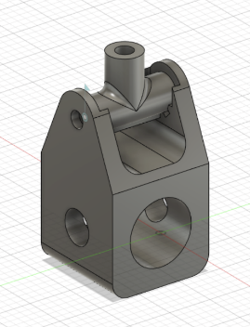

Figure 1: 3D-printed mounting system CAD model.

The first alternative devised was a custom mount intended for 3D printing out of ABS plastic. Ideally this fastener would slide onto the tube through the largest hole at the bottom, and be secured using a bolt/washer/nut assembly through the smaller hole running perpendicular (requiring a hole to be drilled through the tube in the same direction). The secondary hinge assembly would allow for locking to 45-degree angle increments using notches, and would be secured to both the lower tube mount and the panel using more nuts, washers, and bolts. Multiple of these could be secured per tube for panels of varying sizes.

3D-printing this design would allow for variations in the design to be easily accommodated for (e.g. structural changes, variations in hinge axis, different tube diameters, etc). Furthermore, adjustability in angle could allow for novel, more optimal panel arrangements. However, this would likely be a heavier component, and small notches for the angle-lock mechanism could result in sharp stress concentrations leading to failure. 3D-printing this would also likely incur significant manufacturing time penalties as opposed to bending/drilling sheet metal or buying a pre-made component, and possibly cost extra due to the amount of filament used.

### 4.1.2 Ball/Cushion Clip Mount

Figure 2: Image of cushion clip mount

The second alternative chosen is a polymer ball and cushion clip mounting system from Fastcap [2]. Ordinarily meant for furniture, this mount is very simple and can be bought in large quantities. One half would be directly attached to the carbon fibre tube and the other directly to the panel using the built-in mounting points, also likely using bolt/nut assemblies.

This option is extremely light, simple, and cost effective. Furthermore, the ball/cushion nature of the securing system means no tools are needed to remove panels from the car for maintenance. However, there are still issues. Firstly, due to the flat nature of the mount, pressure between the tube and the bottom mounting bracket will be inconsistent, and an additional part may be needed to secure this properly to the tube: this is compounded by the fact that these brackets are not sold in varying sizes. This solution also leaves out the ability to change panel angle relative to the tube. Finally, this option may be more difficult to simulate due to the flexible nature of the mounting system.

### 4.1.3 McMaster-Carr Weld Nut

Figure 3: Image of weld nut

This option is very similar to the ball and cushion mount, but instead of using two halves with a ball and cushion to secure the panel there is one piece with a threaded hole for a bolt instead [3]. This would likely be attached to the tube similarly to the ball/cushion mount, but instead directly use a bolt to attach to the panel.

Similarly, to the previous option, this alternative is simple, light, and cost-effective. It also shares some negative aspects, such as uneven pressure when mounted to the tube (necessitating a secondary component) and a lack of angle adjustability. This option is slightly heavier, being metal, but also slightly simpler and easier to simulate as it is one rigid piece. Tools will once again be required to remove panels for this solution as there are bolts securing panels in place rather than just a ball and cushion.

### 4.1.4 Further remarks

It is worth mentioning that all the above alternatives require at least some drilling into carbon fibre tubing and/or panels. This is not preferable since firstly, carbon fibre is notoriously difficult (and dangerous without proper ventilation) to machine material out of after curing due to it’s lack of ductility, and secondly, such techniques are irreversible and take away from the versatility of the system (i.e. more will have to be planned in advance, and will be locked in once manufacturing is underway without manufacturing extra parts). Further investigation and optimization should involve looking into alternatives that do not require drilling, such as those that involve securing via friction**.**

### 4.2 Design for Doors

The door features will be a critical part for the exterior shell design as the rules and regulations need to be standardized for the door features, and failure to comply will result in not competing for the Queen’s Super Mileage Team. The rule as it states “It is imperative for Drivers, fully harnessed, to be able to vacate their vehicles at any time without assistance in less than 10 seconds”. This rule is important for our team to take note as the door must be large enough for the user to vacate the vehicle with ease and study enough to keep the elements of the race outside. The door design will consist of three main subgroups, and within each subgroup, three designs have been chosen to undergo design analysis and pick the design that will best suit Queen’s Super Mileage Team needs. The three subgroups are door handles for the user to enter and exit the vehicle, door latches to keep the door secured and door hinges to pivot the door to open and close. The latches will help keep the door handle simple and the sheets for the exterior shell are relatively thin, using a door handle such as the one commonly found in your household would not be sufficient enough to keeping the exterior vehicle door closed.

Each three of the designs chosen for each subgroup will be evaluated using design criteria and functional requirements which have been defined above. Each solution has been chosen to be lightweight, easy to manufacture and keeping the cost in mind.

### 4.2.1 Door Handles – Yacht Flush Handle

The yacht flush handle [4] is intended to have minimal exterior protrusion and limit the amount of drag the handle will be facing. With this design, the latch mechanism will be the main solution to keeping the vehicle door shut as the handle will only act to open the car door from the outside of the vehicle. The handle shown below in Figure 4.**Error! Reference source not found.** has a polished surface which makes the handle easy to fold, and easy to open and close the handle.

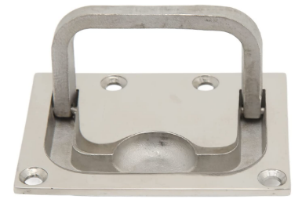

Figure 4: Image of flush yacht handle.

The handle shown above features pre-drilled holes for easy mounting on the door panels as well as pre-countersunk holes that allows the head of the bolt to be flush with the handle face. The handle is approximately 76mm x 56mm which is large enough for a user to open with ease and small enough that the weight can low. The weight of the handle is only 0.136Kg which is a positive to helping the vehicle stay under weight. The material the handle is made from is 316 marine grade stainless steel which feature study construction and maximum wear resistance and durability.

### 4.2.2 Door Handles – Circular Latch

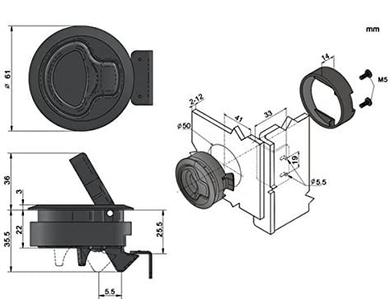The circular latch [5] is a locking circular flush latch that is commonly used in RV’s, campers and marine boats. With the small diameter of 60mm can fit into any 2-inch hole cut out and latch onto a panel or exterior sheeting.

Figure 5: Image of flush circular latch with dimensions.

The latch is made from ABS plastic which from research shows that ABS plastic has a yield strength of 18MPa [6] which will be above any forces that this handle could potentially encounter. The max service temperature of ABS plastic is 76 degrees Celsius which is also above the maximum temperature the handle could experience. This circular handle features UV stabilized black coating which can withstand the harshest outdoor elements. The weight of this handle is 0.06Kg which is half as much as the yacht option shown above as plastic is relatively lighter and easy to manufacture. The handle features a latching mechanism in the handle which can save money on unnecessary spending on extra items not needed.

### 4.2.3 Door Handles – Recessed Pull Handle

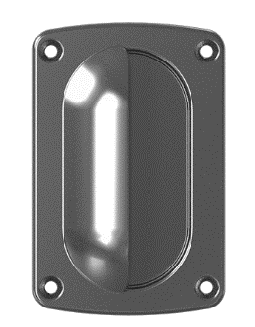The plastic recessed pull handle [7] is commonly used on furniture, machines and equipment to lift or open various mechanisms. This door handle is manufactured using one piece of material and does not contain any moving parts for simplicity.

Figure 6: Image of the recessed handle.

The recessed door handle is made from black plastic which pre-machined holes for easy mounting. This handle is 92mm x 61mm which is a favourable size that a user can still use with ease but not cause enough drag to be noticeable. The temperature rating of this design can withstand temperatures up to 140 degrees Celsius which is above any temperatures the vehicle could encounter. Using plastic as the main material can help keep the cost and weight of the overall vehicle low as plastic is very easy to manufacture.

### 4.2.4 Door Latches – Swinging hook latch

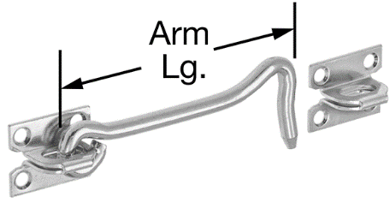The latch design [8] proposed would feature a swinging arm which would have a circular hole to enter through securing each side of the panels. This latch is commonly found around the house holding doors from closing in outdoor sheds and garages along with hotel rooms keeping the door shut and locked.

Figure 7: Image of the swinging hook latch

The latch design is made from zinc-plated steel which has a yield strength of 30 MPa [9] which would be suitable for any forces or conditions the latch may face. The latching arm is 5 inches long which can be easily assessable for the driver to exit the vehicle. The design feature pre-drilled holes for easy mounting on the exterior of the vehicle. The vehicle during the race will not be travelling at high speeds in order to maintain the lowest fuel efficiency, therefore the latch coming loose or off the locking mechanism can still be a downside of this design.

### 4.2.4 Door Latches – Snap latch

The snap latch design [10] is commonly used is outdoor camping equipment and outdoor vehicles where a quick and easy latch is necessary. This design snap together to secure doors. The design also has a return spring to snap tight with a push and release with a pull. The snap latch is 25mm in hight with a width of 38mm which will help to be small enough that will not intrude with the driver. The design features pre-drilled holes for easy mounting. The material is a plastic with a yield strength of 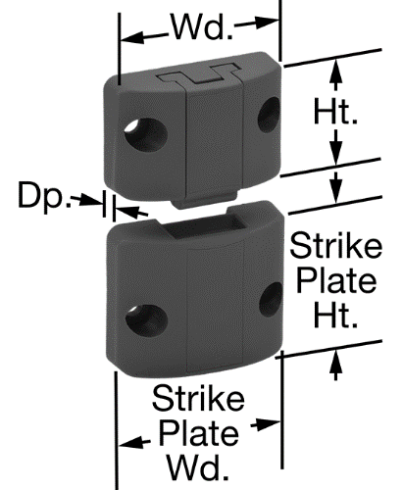50MPa which will be high enough to withstand any forces the latch may encounter.

Figure 8: Image of the snap latches.

### 4.2.5 Door Latches – Bolt latch

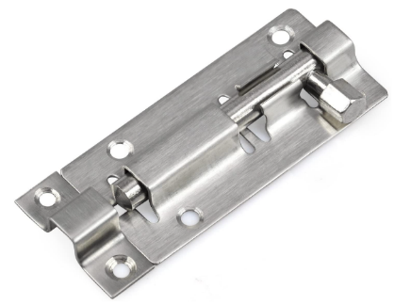The proposed design [11] is commonly used in doorways such as the shed, bathroom or outside garage entrance. This design is easy to install and use for the driver.

Figure 9: Image of the bolt latch

The design features a body that measures 75mm x 35mm which helps to not intrude the driver. The material is 6061 aluminium with a yield strength of 276MPa which is far beyond what the vehicle could withstand. The design is lightweight with a weight of 4.5 grams. This design is simple to install with pre-drilled holes that have been counter sunken to better conceal the head of the bolt.

### A close-up of a handgun Description automatically generated with low confidence4.2.6 Door Hinges – Hidden Circular Hinge

Figure 10: Image of the hidden circular hinge.

Hidden circular door hinges are usually used for cabinets and other domestic interior fixtures with a focus on aesthetics. This hinge will be mounted on the inside of the door and body panel. The 90-degree range of the hinge will also provide easy access while limiting the door’s movement once the end of the hinge’s travel is reached. The proposed design is 7.6 x 1.6 x 2.5 cm in length height and width respectively, while weighing 168 grams [12]. It is also made from what is assumed to be a low-carbon steel with an approximate yield strength of 370 MPa which is sufficient to support the weight of the door.

### 4.2.7 Door Hinges – Locking Lift-off Hinge

Figure 11: Image of the locking lift-off hinge

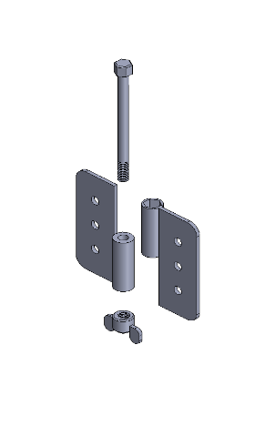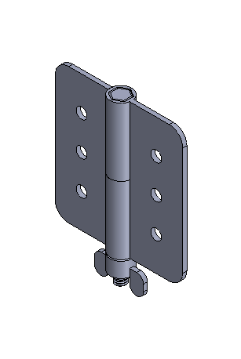

Lift-off door hinges are primarily used in HVAC systems and industrial generators to improve access when performing maintenance. The proposed design is a variation of the traditional exterior mounted lift-off hinge that incorporates a tool-less locking mechanism. The locking mechanism consists of a partially threaded fixed bolt in place of the hinge’s shaft with a nylon insert locking wing nut on the bottom. This design acts like a normal leaf hinge with the added benefit of quick door removal for repairs or maintenance. This design will be a modified version of an off the shelf part or a custom-made part. Based on a commercially available option weighing 210 g [13], the modified version will weigh roughly 270 g with the addition of a wing nut and extended shaft.

### A picture containing metalware Description automatically generated4.2.8 Door Hinges – Marine Hinge

Figure 12: Image of the Marine Hinge

This design was initially intended for use for hatches found on boats. The hinge can be mounted both on the inside and outside of the exterior shell depending on how the panels are mounted. The design of this hinge is also simpler when compared to the other options reducing the likelihood of failure. It is 7 cm long, 6.7 cm wide, and 3 cm tall weighing 216 g [14]. It is also strong enough to withstand the intended use as it is made from 316 stainless steel with a yield strength of 290 MPa with pre-drilled and countersunk holes used for mounting.

### 4.3 Design for Exterior shell

From rules and regulations, the shell panel must cover all mechanical parts when viewed from all side. Therefore, the panel composes the largest weight of the whole shell design, and the potential cost and manufacturing time is high. Three panel materials are listed and discussed in the existing manufacturing methods. Under further research, three alternative solutions are proposed for the shell panel.

### 4.3.1 Plain carbon

The first panel option is plain weave carbon as shown in the figure [15]. This carbon sheet has checkerboard style pattern, and the tows are woven in an over and under pattern. The material is highly stabilized. Car manufacturers like Audi specifically use carbon fibre to replace the steel parts to reduce the total weight.

Figure 13: Image of plain carbon

The plain carbon has a high level of stability which makes it suitable for flat sheets and tubes. The exterior shell of the vehicle requires flat panel at the top and two sides. Plain weave carbon is a strong candidate. This material is lightweight and weighs 161.59 grams with an area of 50” × 300”. It greatly reduces the total weight of the shell comparing to the usage of metal materials.

### 4.3.2 Twill carbon

Twill weave carbon is very similar to the plain weave carbon in appearance [16]. This material creates a diagonal arrowhead pattern as shown in the figure. 2×2 Twill carbon is widely used in cosmetic and decorative applications.

Figure 14: Image of twill carbon

Comparing to plain carbon, twill carbon has better pliability which make it suitable for some complex contours design. At the same time, twill carbon is less stable than plain carbon and it is slightly heavier than plain carbon with 164.43 grams over area of 50” × 300”.

### 4.3.3 plain weave S-glass

The plain weave S-glass is commonly used as waste release fabric for glass bending, surfboards and skis. S-glass displays same pattern as plain carbon, but they compose of different material as shown [17].

Figure 15: Image of plain weave S-glass

Plain S-glass is the cheapest material among three designs, and it is easy to manufacture. The material is dense which brings it a superior impact strength and abrasion resistance. The wight of the S-glass is 113.39 grams over an area of 30” × 300”.

### 4.4 Design for Windows

Windows are the critical component in the vehicle body parts as they mainly affect the safety and visibility of drivers. As Shell Eco-Marathon Competition Rule stated, ‘Windows must not shatter into sharp shards. Protective film covering the windows is allowed but must not distort the driver’s visibility. The side windows tinting must be light enough to allow the driver to be seen from outside the vehicle’ [1], indicating that windows are the top priority for drivers to safely proceed driving manoeuvres. Windows includes front and rear windshields, side door windows and rear-view mirrors.

### 4.4.1 Polycarbonate Sheet

At only half the weight of glass, these polycarbonate sheets [18] are great fit for windows. They have excellent impact strength that meet UL 972 are rated as burglar resistant. Additionally, performance properties of the sheet are clear vision, high Strength, impact resistant, low thermal expansion, and weather resistant. However, it has low light transmission of 50% meaning that driver’s visibility standard will not be met unless a see-through material is obtained.

Figure 16: Image of a polycarbonate sheet.

### 4.4.2 Impact-Resistant Polycarbonate Film

The polycarbonate film can protect window panels and other surfaces from shattering into sharp shards. It has excellent tensile strength and impact strength. The hardness level is Rockwell R118 which is classified as hard. This film is relatively cheap, only $5.21 per 24’’ x 48’’ film.

### 4.4.3 Scratch and UV-Resistant Cast Acrylic Sheet

This 48’’ x 48’’ sheet is made of acrylic plastic. It has high tensile strength but poor impact strength. This material is scratch and UV resistant; it stands up to outdoor use better than polycarbonate and maintains clarity over time [19].

## 5.0 Selection Methodology

All five design solutions outlined above were evaluated using the Quality functional Deployment. As a group our team ranked the three choices from “worst” to “best” for each characteristic listed above in Design Criteria. The evaluation was done anonymously and decided on our numbers with an explanation and logic to ensure that the correct numbers are being used. The final ranking of the designs was completed by taking the weighted average of the category and summing all the categories together to find which design would have the highest score. The weighting of each design has been previously determined from initial discussion with the client’s needs and discussion with the team members.

It should be noted, that because these designs are only proposed and not fully developed, several assumptions were made during the ranking process and these scores are therefore subject to change when new information becomes available. Once a design has been selected, it will undergo iterations and development where the conditions will be reassessed to ensure that it continues to meet the functional requirements.

### 5.1 Proposed Design

### 5.1.1 Panel Attachments

For this category, modularity, adaptability, and weight are prioritized, as this system particularly needs to be extremely versatile to allow for many permutations while still staying lightweight to maximize performance. Manufacturing time and cost are important but less so as ideally these components can be arranged and tested in a wide variety of ways using CAD software to minimize cost before being ordered or manufactured in house- Furthermore, there is a significant budget allowed and other components are significantly cheaper. Finally, the nature of a modular design system is due to be inherently complex as a trade-off for versatility.

The results of this evaluation can be found in the evaluation matrix in Table 1 in the Appendix. All three alternatives ranked similarly to each other for different reasons, clearly signalling that a compromise is not only possible, but necessary. The versatility of the 3D-printed option is highly desirable, but pre-made mounting brackets offer cheap and simple options particularly for attaching to the flat carbon fibre panels that are pre-made to specific standards.

Figure 17: Sketch and CAD model of the 3D-printed panel mounting system.

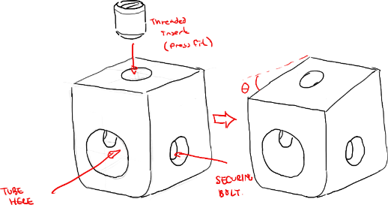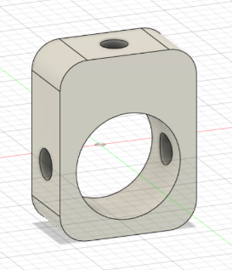

Thus, the proposed alternative uses the bottom half of the 3D-printed option with attachment points for the panel integrated directly into the top of the part. The mounting surface of the 3D-printed part can be printed at different angles, and a variety of parts will be designed with differently-angled mounting surfaces. A hole will be integrated into the top of the 3D-printed part to fit a press-fit threaded insert from McMaster-Carr, onto which the panel can be directly secured with a bolt and washer (and will expand into the plastic in the process, ensuring a snug fit). While this obviously sacrifices some of the simplicity of just one weld nut or bracket, it maintains significant versatility from the first 3D-printed alternative while significantly simplifying the securing mechanism to the panel itself.

### 5.1.2 Door Attachments

For the proposed design of the door, a design matrix has been used with various weightings of customer and technical categories. Using categories that have been outlined in 3.0 Design Criteria and Functional Specifications, a weighting has been added to each category to outline the importance of each category to the specific design idea. All three ideas were ranked against each other and whichever idea had the highest number would be the best option to choose for our design.

The door handles were all evaluated using the design matrix found in 9.0 Appendix in which the reseeded door handle has been found to be the best option. With its simplicity and ease of access it makes the reseeded handle the best option.

The door latches are a similar result with the simplicity being important for our final design. The swinging latch design will be the best option. The swinging door latch is easy to use, easy to mount and due to the low speeds of the vehicle will allow for a simple and easy to use option.

The proposed design for the door hinge after considering the available options was the marine hinge. When entered into a design matrix found in the Appendix to assess the designs based on the client’s requirements the marine hinge scored best. The hinge’s high score was due to good performance in the highly weighted categories of manufacturing time, complexity, and adaptability. Where the hinge’s easy sourcing, simple design, and versatile mounting options put it above the other options.

This contrasts with the locking lift-off hinge whose design allowed for good modularity without the need to remove the hinge to replace the door but suffered due to the added effort and cost associated with its manufacturing. The hidden circular hinge also suffered in modularity, complexity, and adaptability compared to the marine hinge. This was due to its complex design and the fact that it can only be mounted on an interior panel.

### 5.1.3 Exterior Panels

The proposed design for the exterior panel was the plain weave carbon. Three potential design solutions were evaluated using the design matrix shown in Table 2. For the panel selection, cost, manufacturing time, and weight are prioritized. The weave carbon fibre had higher score than glass fibre due to its light-weight property. Glass fibre are the densest among three designs which results in the largest weight and lowest tolerance to error during manufacturing. Plain weave carbon and twill weave carbon presented similar modularity, complexity, and manufacturing time. Plain weave carbon was slightly lighter and lower in cost compared to twill weave carbon. And Plain weave was found to be highly stabilized which is suitable for shell panel.

## 6.0 Deliverables

Gantt chart of this project is outlined into report deliverables and team deliverables. The report deliverables include proposal report, biweekly progress reports and final report. The team deliverables mainly contain design aspects such as design for attachment, doors, windows, etc. The overall time length of completing the deliverables is approximately six weeks.

## 7.0 Economic Analysis

An economic analysis of each of the six designs have been evaluated below. The exterior shell teams have been given a budget of $8000 CAD in which our team needs to stay below. It is important to note that the prices below are not fixed and do not have any shipping or any other additional costs with them. The analysis below does not take into account any spares or extra parts the shell may need throughout the competition to be replaced due to wear or damage caused by outside sources.

Table 1: Economic analysis of the proposed parts and designs.

|  |  |  |
| --- | --- | --- |
| **Part** | **Total Price** | **Reference** |
| **Attachment** | 100*((3*9) +2.15) +10*9.04+2(13.25) = $3031.90 | [20] [21] [22] |
| **Door Handle** | $3.45CAD x 2 = $6.90 | [4] [5] [7] |
| **Door Latch** | $6.37 x 2 = $12.74 | [8] [10] [11] |
| **Door Hinge** | $22.39 x 2 = $44.78 | [14] |
| **Exterior Panels** | $34.49 x 3 = 103.47 | [15] [16] [17] |
| **Exterior Windows** | $48.64 x 3 + $5.21 *3 = $161.55 |  |
| **Final Cost** | $3361.34 | |

Each part is approximately 3 cubic inches in volume: assuming 100 total attachment points and a price of 9$ per cubic inch from the ILC 3D printer, this results in 3D printed attachment points costing approximately $2700. 100 M8 x 12.7 thread inserts from McMaster-Carr will cost approximately $215. 100 M10 x 50 partially threaded bolts from McMaster-Carr to secure mounts to the tube will cost approximately $90.40, while 100 M8 x 16 fully threaded bolts to secure the panel to the threaded insert will cost $26.50. This adds up to a total cost of $3031.90.

## 8.0 Conclusion

Overall, our team proposes a versatile, reliable, and performant modular system for designing, testing, and iterating upon bodyshell configurations for the QSM urban concept vehicle that makes use of a combination of custom and externally-sourced parts. Even with significant budget taken up by custom attachment points and the necessary hardware, our team has a vast amount of wiggle room to accommodate for design changes and unexpected costs. With the selected design concepts for each of the six main categories for bodyshell parts, rigorous testing and iteration will be conducted to further optimize the performance of each segment, as well as ensure that each portion functions synergistically with every other component. The most important testing to come in subsequent project stages is FEM, both on individual components and complete systems of components, to ensure that design concepts are properly stable under realistic load scenarios.

## 9.0 Appendix

Table 2: Design Matrix for the six design ideas.

|  |  |  |  |  |  |  |  |  |
| --- | --- | --- | --- | --- | --- | --- | --- | --- |
| **Design Matrix: Attachment** | | | | | | | | **Total** |
| **Items** | **Cost** | **Manufacturing time** | **Tolerance for error** | **Complexity** | **Modular** | **Adaptability** | **Weight** |
| **Weighting (%)** | **6** | **10** | **3** | **8** | **22** | **24** | **27** |  |
| 3D printed Mount | 3 | 3 | 7 | 2 | 8 | 9 | 3 | 558 |
| Mounting Clip | 5 | 8 | 4 | 8 | 4 | 2 | 8 | 538 |
| Weld T-nuts | 7 | 8 | 5 | 9 | 3 | 3 | 8 | 563 |
|  |  |  |  |  |  |  |  |  |
| **Design Matrix: Door Handles** | | | | | | | | **Total** |
| **Items** | **Cost** | **Manufacturing/Install time** | **Tolerance for error** | **Complexity** | **Modular** | **Usability** | **Weight** |
| **Weighting (%)** | **27** | **24** | **6** | **22** | **3** | **10** | **8** |  |
| Marine Latch | 5 | 7 | 8 | 8 | 3 | 8 | 7 | 672 |
| Circular Latch | 8 | 6 | 5 | 7 | 3 | 7 | 8 | 687 |
| Recessed Handle | 7 | 7 | 8 | 9 | 3 | 9 | 8 | 766 |
|  |  |  |  |  |  |  |  |  |
| **Design Matrix: Door Hinges** | | | | | | | | **Total** |
| **Items** | **Cost** | **Manufacturing time** | **Tolerance for error** | **Complexity** | **Modular** | **Adaptability** | **Weight** |
| **Weighting (%)** | **27** | **24** | **6** | **22** | **3** | **10** | **8** |  |
| Locking Lift-off Hinge | 5 | 5 | 6 | 6 | 8 | 8 | 6 | 575 |
| Mairne Hinge | 7 | 9 | 8 | 9 | 8 | 8 | 7 | 811 |
| Hidden circular hinge | 8 | 9 | 8 | 7 | 7 | 7 | 8 | 789 |
|  |  |  |  |  |  |  |  |  |
| **Design Matrix: Exterior Panels** | | | | | | | | **Total** |
| **Items** | **Cost** | **Manufacturing time** | **Tolerance for error** | **Complexity** | **Modular** | **Adaptability** | **Weight** |
| **Weighting (%)** | **27** | **18** | **6** | **12** | **3** | **10** | **24** |  |
| 1x1 weave | 7 | 6 | 8 | 8 | 8 | 8 | 9 | 761 |
| 2x2 weave | 5 | 6 | 8 | 8 | 8 | 8 | 8 | 683 |
| 1x1 fibreglass weave | 8 | 8 | 5 | 7 | 7 | 6 | 6 | 699 |
|  |  |  |  |  |  |  |  |  |
| **Design Matrix: Door Latches** | | | | | | | | **Total** |
| **Items** | **Cost** | **Manufacturing/Install time** | **Tolerance for error** | **Complexity** | **Modular** | **Usability** | **Weight** |
| **Weighting (%)** | **27** | **24** | **6** | **22** | **3** | **10** | **8** |  |
| Swinging Hook Latch | 10 | 9 | 8 | 9 | 5 | 9 | 8 | 901 |
| Snap Latches | 8 | 8 | 6 | 7 | 5 | 8 | 9 | 765 |
| Bolt Latch | 9 | 9 | 7 | 8 | 5 | 8 | 8 | 836 |
|  |  |  |  |  |  |  |  |  |
| **Design Matrix: Window** | | | | | | | | **Total** |
| **Items** | **Cost** | **Manufacturing time** | **Tolerance for error** | **Complexity** | **Modular** | **Adaptability** | **Weight** |
| **Weighting (%)** | **27** | **24** | **6** | **22** | **3** | **10** | **8** |  |
| Lexan Polycarbonate | 5 | 7 | 8 | 7 | 6 | 7 | 9 | 665 |
| Polycarbonate film | 9 | 8 | 9 | 8 | 7 | 5 | 8 | 800 |
| Acrylic clear sheets | 6 | 7 | 9 | 8 | 6 | 8 | 8 | 722 |

|  |  |  |  |  |
| --- | --- | --- | --- | --- |
| Task Mode | Task Name | Duration | Start | Finish |
| **Manually Scheduled** | **Report Deliverables** | **40 days?** | **Mon 22-10-17** | **Fri 22-12-09** |
| Auto Scheduled | Proposal Report | 6 days | Mon 22-10-17 | Mon 22-10-24 |
| Auto Scheduled | Progress Report Wk 7-8 | 9 days | Tue 22-10-25 | Sun 22-11-06 |
| Auto Scheduled | Progress Report Wk 9-10 | 10 days | Mon 22-11-07 | Sun 22-11-20 |
| Auto Scheduled | Progress Report Wk 11-12 | 10 days | Mon 22-11-21 | Sat 22-12-03 |
| Manually Scheduled | Final Report | 6 days | Sun 22-12-04 | Fri 22-12-09 |
| **Manually Scheduled** | **Team Deliverables** | **29 days?** | **Tue 22-11-01** | **Fri 22-12-09** |
| Manually Scheduled | Design Solutions | 20 days | Tue 22-11-01 | Mon 22-11-28 |
| Manually Scheduled | Design for Exterior Shell | 8 days | Tue 22-11-01 | Thu 22-11-10 |
| Manually Scheduled | Design for Attachment | 6 days | Wed 22-11-09 | Wed 22-11-16 |
| Manually Scheduled | Design for Doors | 6 days | Thu 22-11-17 | Thu 22-11-24 |
| Manually Scheduled | Design for Windows | 1 day | Fri 22-11-25 | Fri 22-11-25 |
| Manually Scheduled | Design Exhibition Poster | 6 days | Sun 22-12-04 | Fri 22-12-09 |